**Member Contribution – Team Annex**

**Roles**

Brian Olsen

1. Navigation functionality
2. Database interaction
3. 1st interview: observer
4. 2nd interview: note taker
5. 3rd interview: interviewer

Joshua Koehn

1. Updated RoomView GUI
2. Added KioskSelection GUI
3. Connected the modules/GUIs together
4. Member contributions
5. 1st interview: note taker
6. 2nd interview: interviewer

Richard Blotevogel

1. Designed GUIs
2. Obtained all extra images
3. Wrote interview script
4. Field Notes
5. 1st interview: interviewer
6. 2nd interview: observer
7. 3rd interview: note taker

**Team Minutes**

Team Meeting 1 3-20-13 8:00am - 10:30am

We finished all the documentation (except from the third interview) for phase 3.

` We also began to brainstorm on our plan for phase 4.

Called and scheduled interviews.

Our plan for how the Direction GUI will look:

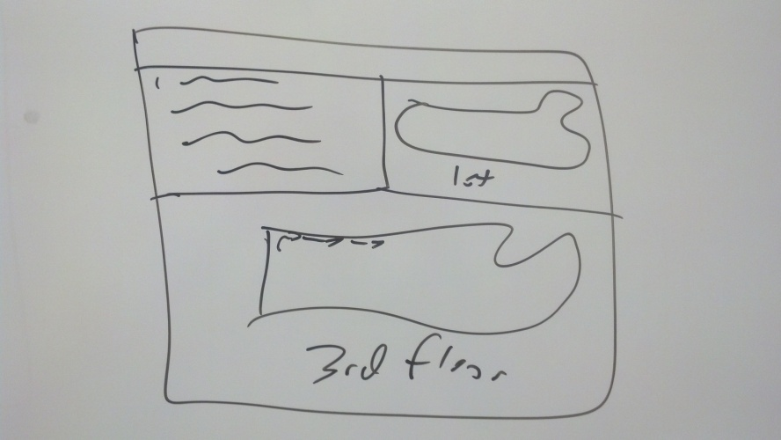

Team Meeting 2 3-26-13 4:30pm – 6:00am (3-27-13)

Worked on our separate parts while asking the other’s opinion at times . Also worked at integration to make sure everything was ready for interviews. Brian and Joshua were at school all night

NOTE: Originally had interview 1 scheduled for 9am on 3-27-13 with Brandon Blaylock, but he did not show

up. (He was supposedly in a small car accident) We found an alternate student to interview at 10:30 (since no one had reserved the HCI lab).

Team Meeting 3 3-27-13 9:00am – 10:30am

Called/scheduled a new student for interview 1. Discussed/made changes to prototype and interview script.

Interview 1 3-27-13 10:30am – 11:00am

Student: Andrew Stubblefield Interviewer: Richard Blotevogel

Note Taker: Joshua Koehn Observer: Brian Olsen

Stayed afterward to pull the video off of the computer.

Interview 2 3-27-13 11:00am – 12:00pm

Student: Erin Gourly Interviewer: Joshua Koehn

Note Taker: Brian Olsen Observer: Richard Blotevogel

We met about 30 minutes before the interview to make sure that everything was ready.

Stayed afterward to pull the video off of the computer.

Interview 3 4-1-13 9:00am - 10:00am

Student: Cathy Casey Interviewer: Brian Olsen

Note Taker: Richard Blotevogel Observer: n/a

We met about 30 minutes before the interview to make sure that everything was ready.

Stayed afterward to pull the video off of the computer and get everything ready to submit.